CONNECT TO AWS
CREATE ACCOUNT IN AWS
AND SIGN IN

CLICK ON EC2
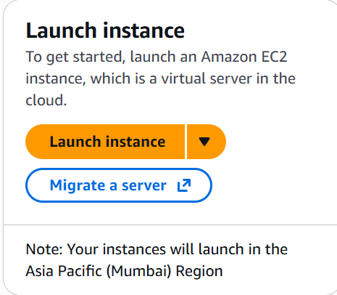
CLICK ON LAUNCH INSTANCE

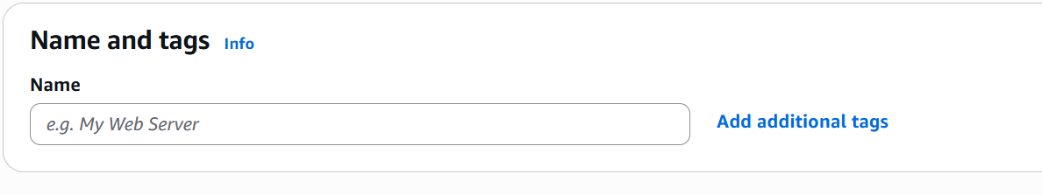
CREATE ANY NAME
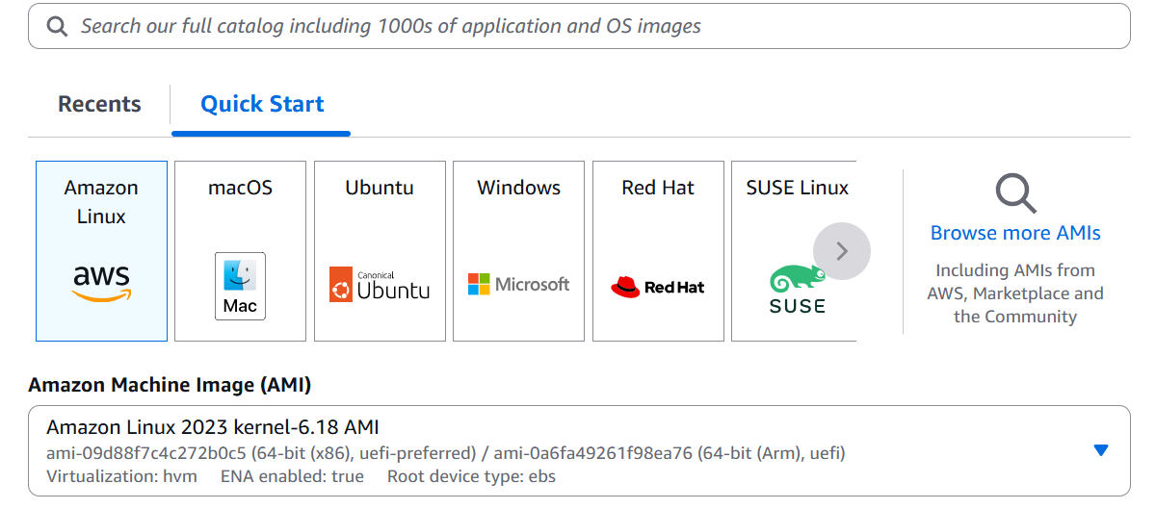
SELECT UBUNTU
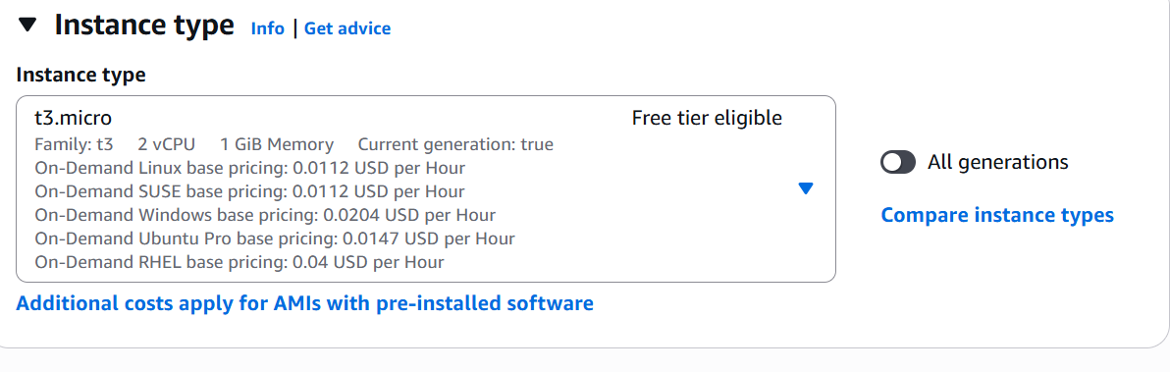
SELECT T3 MICRO
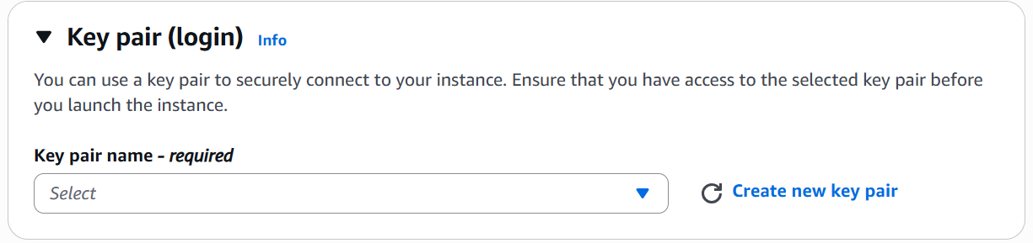
SELECT CREATE NEW KEY PAIR
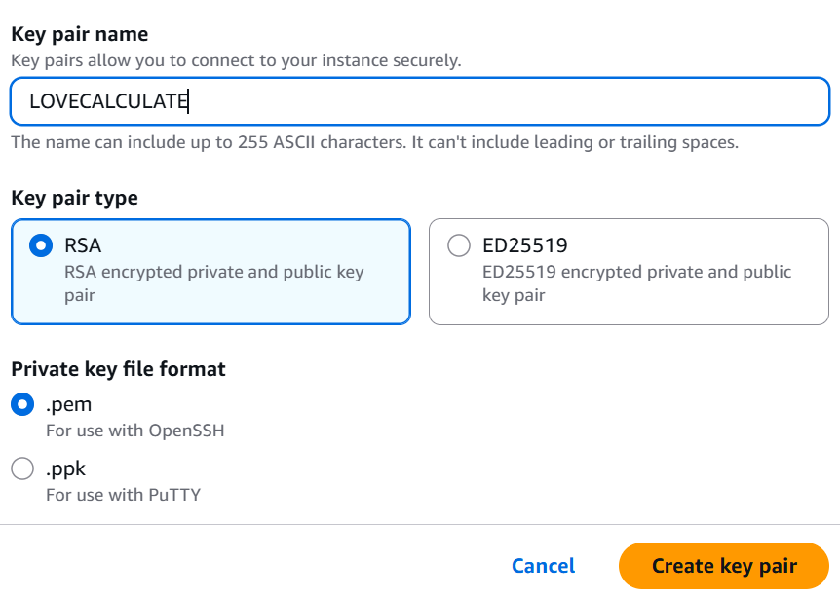
CREATE A NAME AND CLICK ON CREATE KEY PAIR
- ✅ Key Pair Name: LOVECALCULATE
- ✅ Key Pair Type: RSA
- ✅ Private Key File Format: .pem
Now click the Create key pair button.
IT WOULD DOWNLOAD A FILE
LAUNCH EC2 INSTANCE
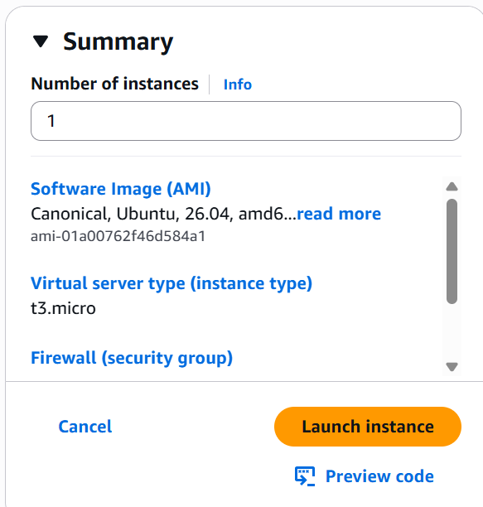
After the instance is running
Go to:
EC2 → Instances
Click on your instance.
You will see details like:
Instance ID
Public IPv4 Address
Private IPv4 Address
Instance State
Security Group
Look for Public IPv4 Address. It will look similar to:
13.233.145.120

Connect to instance and execute the below commands
Update-> sudo apt update
sudo apt upgrade -y
Step 2: Install Python and Nginx
Run:
This installs the latest security and software updates.
- sudo apt install python3-pip python3-venv nginx sqlite3 -y

This installs:
- python3-pip → Install Python packages
- python3-venv → Create virtual environments
- nginx → Web server
- sqlite3 → SQLite database tool
According to your folder
Update script.js with instance ip address
const response = await fetch("http://127.0.0.1:8000/calculate", {
TO
const response = await fetch("http://<public-IP>:8000/calculate", {
*Upload love Calculator files from vs code so execute the below command

scp -i "C:\Users\niran\Downloads\LOVECALCULATE.pem" * ubuntu@13.201.229.214:/home/ubuntu/
verify the files in ec2 instance server
goto ec2 instance
>ls
Ex:
database.py home.py index.html love.db script.js styles.css
copy html CSS java script files into /var/www/html/
command: sudo cp index.html script.js styles.css /var/www/html
verify the files
command: ls /var/www/html

Create a Virtual Environment
Run:
python3 -m venv myenv
After it completes, activate it:
source myenv/bin/activate
Your prompt should change to:
(myenv) ubuntu@ip-172-31-0-121:~/LoveCalculator$

Install Your Python Packages
Run:
pip install fastapi uvicorn sqlalchemy pydantic

verify ->pip list
start uvicorn server
command : uvicorn home:app –reload

next

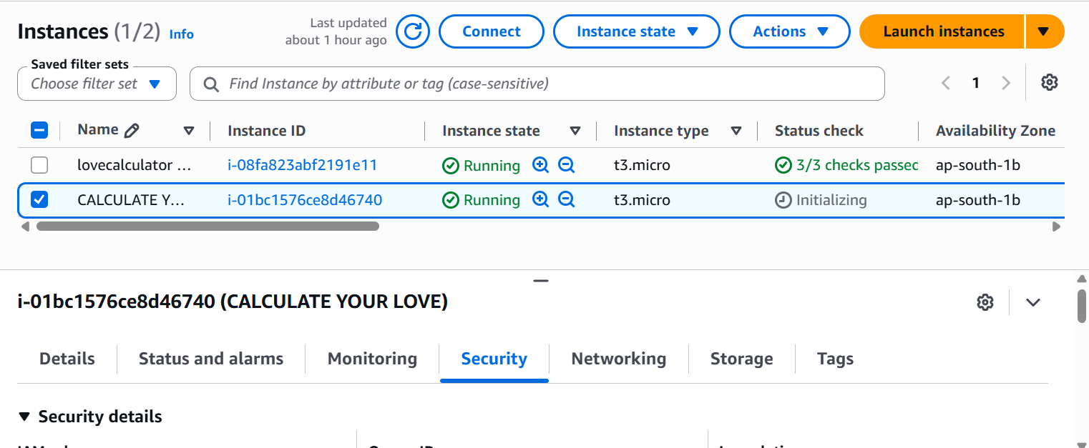

Select instance -> Security
Click on security group id
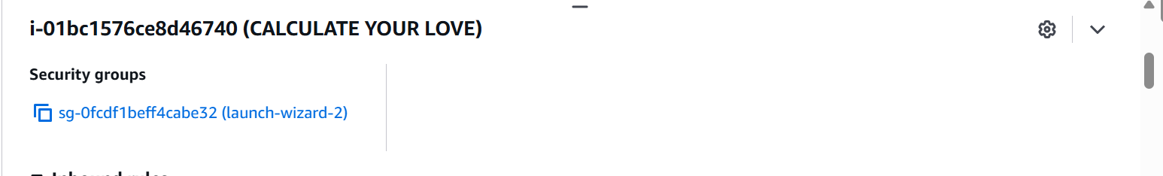
Click on edit inbound rules->add rules
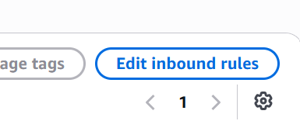
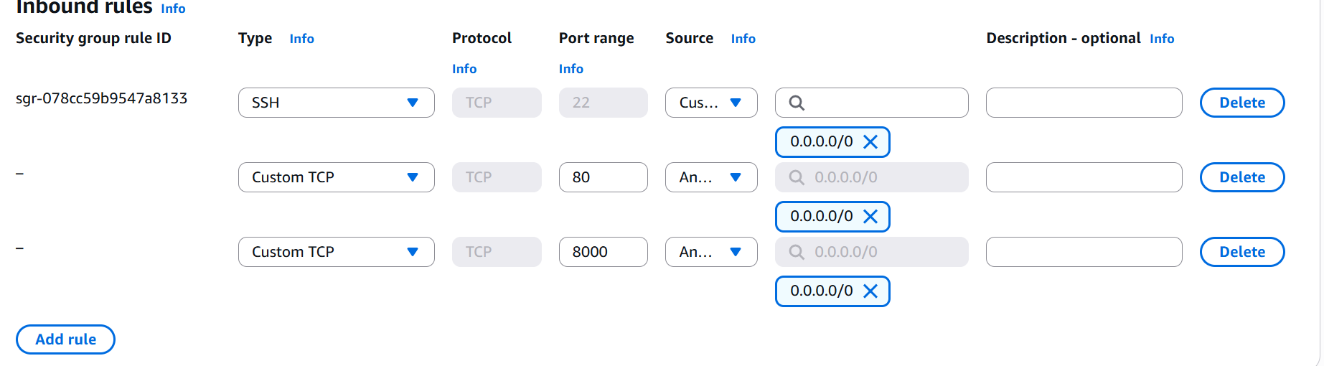

uvicorn home:app --host 0.0.0.0 --port 8000

